MSS Quickstart Reference Guide

# Welcome

Thank you for participating in system testing for the Videoray vectored MSS vehicle. We appreciate the opportunity to work with you on this project.

# Setting up the system

## Unpacking the Vehicle

1. Open the vehicle case, and unbuckle the packing strap around the vehicle.
2. Remove the top layer of foam from the case.
3. Reaching down the side of the vehicle, release flip the lever on the locking clamps to release the vehicle frame from the case.
4. Grip the vehicle by the yellow handles and remove it from the case
5. Place the vehicle upside down on a level surface and attach the skid-pod adapters and skid pods to the mount points on the frame:
   1. The skid pod adapters are designed to be installed on the inboard sides of the frame, with the hinge on the skid pods facing aft on the vehicle.
   2. Align the two pins on the skid pod adapter with the holes in the frame and press the adapter flush against the inboard side of the frame
   3. Insert cotter pins or clips into the holes on the skid pins to secure the skid pod adapters in place.
   4. Repeat for the other side.

## Connecting the System

1. Set the Mission Control Panel (MCP) on a dry, level surface.

Unlatch the lid, and open the case. Position the lid at a suitable angle (~90 degrees) and tighten the sleeve on the monitor support arm.

1. If desired, use tie-downs on the case handle to secure the case to the work surface to prevent accidental tipping of the case.
2. Connect the female end of the 8-pin tether to the power module on the MSS vehicle (ROV). Secure the tether in place with the red locking sleeve.
3. IMPORTANT: Connect all four (4) points of the strain relief harness on the ROV to the strain relief webbing on the tether using the stainless steel C-link. Make sure the nut on the link is closed securely.
4. Connect the male end of the 8-pin tether to the whip on the right-hand side of the MCP. Secure with the black locking collar.
5. Connect the monitor cable from the MCP (HDMI) to the VGA port on the HD monitor installed in the lid of the MCP.
6. Connect the industrial hand controller USB plug to the USB ports located on the lower left of the MCP.
7. Connect the IEC connector on the GFCI equipped power cord to the IEC adapter on the MCP (top left of the panel)
8. Plug the GFCI into the power outlet for the vehicle. For best performance, the outlet should be rated for 20A on 110V AC power.

## Pre-flight Inspection

A pre-flight inspection of the vehicle and system should be performed prior to every dive to ensure the system is ready for operations. The following items should be checked:

* Check tether connection to ensure locking rings on tether and vehicle power converter are secure.
* Check to ensure vehicle strain relief harness is connected to the tether strain relief webbing and C-link is secure.
* Using a 7/16” nut driver, ensure all propeller collets are snug. CAUTION: Ensure vehicle power is off before servicing propellers. Use a glove or towel when handling props, as the edges are sharp.
* Inspect each thruster for leaks or cracks in housing.
* Inspect camera dome retention ring to ensure it is tightly fit to the camera housing.
* Inspect all 9-pin and 5-pin connections visible to ensure there are no open ports on the vehicle. This is especially important after a module has been removed or replaced on the vehicle.
* Ensure all float blocks and fairings are tightly secured to the vehicle frame.

## Ballasting

Once pre-dive inspection is complete, ballasting of the vehicle should be performed if the service conditions (i.e. operation environment) have changed since the last operation. This is particularly important when switching from freshwater operation to seawater, or vice versa. Ballasting of this MSS vehicle is accomplished in much the same way as the Pro4 vehicle, using skid pods affixed to the underside of the vehicle and brass ballast weights. Should supplemental ballast be required, round “doughnut” weights (Pro3) can be affixed to the M6 threaded holes on the underside of the vehicle using appropriately sized screws. In the event metric M6 screws are not available, the holes may be re-tapped for ¼”-20 threads using a tap or stainless screws.

After proper ballasting, the vehicle should be slightly positive, with the top of the center float block should be just above the water line.

# Flight and Operation

## Launching the software

1. Prior to powering up the system, ensure the red ROV power button is depressed.
2. Turn the panel toggle switch to the “ON” position to power up the panel and monitor.
3. Once the login screen appears on the panel, log on to the “videoray” account using the password “videoray”.
4. When the desktop is displayed, you are clear to power up the ROV. To do this, twist the red knob on the top of the panel in the clockwise direction. Listen for the vehicle start-up tone.
5. Launch the vehicle control software by double-clicking the MSS_Launch icon on the desktop.
6. Launch the vehicle video system by double-clicking the appropriate icon on the desktop.
   1. For live video only (no recording), double-click the “Live Video” icon.
   2. To record the mission, click the “Record” icon.
7. Splash the vehicle gently, or use the tether to lower the vehicle into the water.

## Controls

Vehicle control is accomplished through the videoray industrial controller. The flight controls are as follows: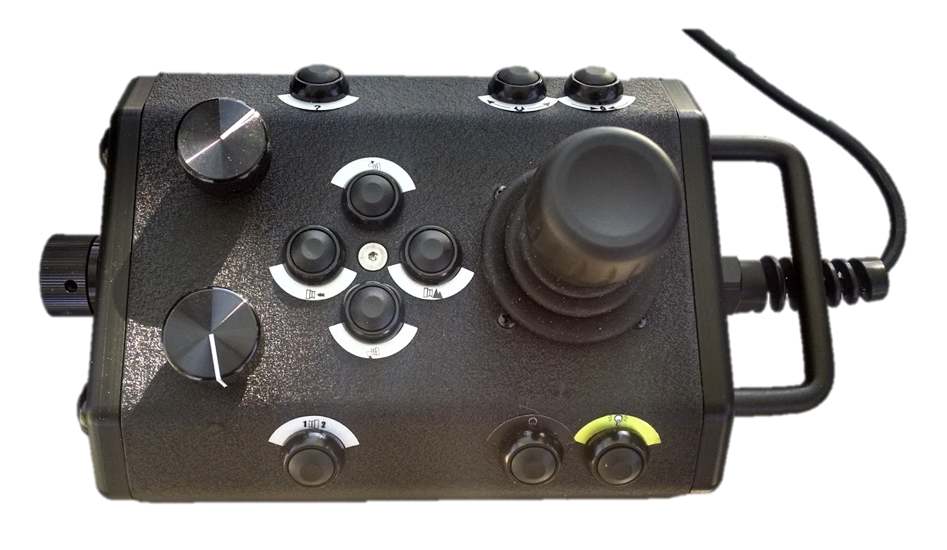

Camer Tilt Up

Camera Tilt Down

Vertical Thrust

LED Control

Manip Close

Camera Center

Manip Open

Disengage LED Safety

# Data Retrieval

Video data recorded by the system is automatically stored in the “Video” folder of the home directory. To access it, click on the “Filing Cabinet” icon in the launcher bar on the left of the screen, and selecting the “Videos” folder. Video files are recorded in MJPEG format, and can be copied to an external drive by dragging and dropping the files to the new drive window.

# Closing the System

## System Shut-down

1. Close the video window by clicking the red “X” in the top left-hand corner of the window, or press *Ctrl-C* with the terminal window for the video (black background with white text) in focus.
2. Close the
3. Press the red shut-off switch on the top of the panel to kill power to the ROV.
4. Retrieve the vehicle from the water, and place it on a level surface to drain.
5. Shut-down the MCP computer by clicking the gear icon in the top right corner of the screen, and selecting “Shut-down”.
6. Power off the MCP using the toggle switch in the top left corner of the panel.

## Post-Flight Inspection

Following retrieval of the system, perform a post-flight inspection of the vehicle in the same manner as the pre-flight inspection. Note any damage, changes, or modifications to the system in the operation log if required.

## Disconnecting and packing

1. Disconnect all cables and wires in the reverse order of connection (see Connecting the )
2. Rinse the vehicle with clean, fresh water prior to packing
3. Disconnect the skid pod adapters and remove from the vehicle.
4. Once dry, place the vehicle back into the cradle inside the transit case. Align the holes in the frame with the clamps on the cradle.
5. Engage the rear clamps by flipping the red lever in towards the vehicle.
6. Secure the vehicle to the cradle using the yellow strap. Ensure the buckle is fastened before closing the case.

# System Maintenance

## General Troubleshooting

Many connectivity or video issues can be solved by cycling power on the sub (420v) using the red switch on the panel. This typically resolves most connection issues with the

## Replacing Vectored Thrusters

1. Remove the top float block by removing the four (4) screws on the top of the vehicle, and lifting the float up and back at an angle. If the float catches on the forward vertical thruster, rotate the thruster until it clears the float.
2. Remove the forward fairings (if replacing a forward thruster) by loosening the two (2) thumb screws on the bottom of the fairing.
3. Trace the thruster whip back to the main thruster stack (located under the main float) and disconnect the damaged thruster from the stack.
4. Carefully thread the disconnected whip and connector back through the frame until it is clear.
5. Using the 10mm wrench or socket driver, loosen the two (2) plastic thruster bolts securing the vectored thrusters to the frame.
6. Note the position of the damaged thruster in the vehicle chassis. The position of the damaged thruster will determine the configuration parameters to be programmed into the replacement.
7. Remove the damaged thruster from the vehicle. If the prop is still in good shape, remove it from the damaged thruster using a 7/16” nut driver. Set prop aside for installation on new thruster.
8. Note the serial number for the new, replacement thruster. This number will be used to identify and program the new thruster once installed in the vehicle.
9. Install the new replacement thruster in the same location as the damaged one, and thread the cable and connector through the same routing as the old thruster. Connect the 5-pin to the same location in the connector stack as before.
10. Mount the thruster to the frame using the M6 nylon bolts, and the 10mm nut driver.
11. Boot the system, and power up the vehicle. Launch a terminal program (from the dock) and use the following commands to program the thruster:
    1. To enumerate the modules on the system type: vr_enum
    2. The new thruster serial number should appear in the list of attached devices.
    3. To initialize the new thruster, type: vr_setid [SN] [Node ID] [Group DI] using the serial number (SN) of the new thruster, and the node ID and group ID from the thruster configuration table below
    4. Vr_enum again to verify the new thruster is registering.
    5. Once complete, type: cd ~/flighthack
    6. To enter diagnostic mode on the new thruster, type: python ./vr_debug_putty.py [NID] where [NID] is the node ID of the new thruster.
    7. Press c in the small terminal window
    8. Run python ./vr_debug_putty [NID] and replace NID with the node ID of the thruster you wish to program
    9. When the thruster enters diagnostic mode (main menu in putty window), press the “c” key to enter the configuration menu.
    10. Change the necessary values in the above table (enter the option number and “Enter”, then the value and “Enter”).
    11. Press the “s” key and “Enter” to save the configuration.
    12. Press the “x” key and “Enter” to exit the configuration menu.
    13. Press the “x” key again to exit diagnostic mode.
    14. Close the putty window

Thruster Configuration Table:

|  |  |  |  |  |  |  |
| --- | --- | --- | --- | --- | --- | --- |
| **Thruster Position** | **Reverse**  **(Option 2)** | **Max Power**  **(Option 17)** | **Node ID**  **(Option 29)** | **Group ID**  **(Option 30)** | **Motor ID**  **(Option 31)** | **Propeller** |
| Forward Port | DISABLED | 600 | 5 | 129 | 0 | Right-Hand |
| Forward Starboard | ENABLED | 600 | 6 | 129 | 1 | Left-Hand |
| Aft Starboard | DISABLED | 600 | 7 | 129 | 2 | Right-Hand |
| Aft Port | ENABLED | 600 | 8 | 129 | 3 | Left-Hand |
| Forward Vertical | DISABLED | 600 | 9 | 129 | 4 | Right-Hand |
| Aft Vertical | ENABLED | 600 | 10 | 129 | 5 | Left-Hand |

Propeller Direction Nomenclature

## Replacing the Camera

## Replacing the LED

LED replacement can be accomplished using similar methods as those described in the Replacing Vectored Thrusters section. Parameters for the LED replacement are as follows:

* Node ID: 11
* Group ID:
* 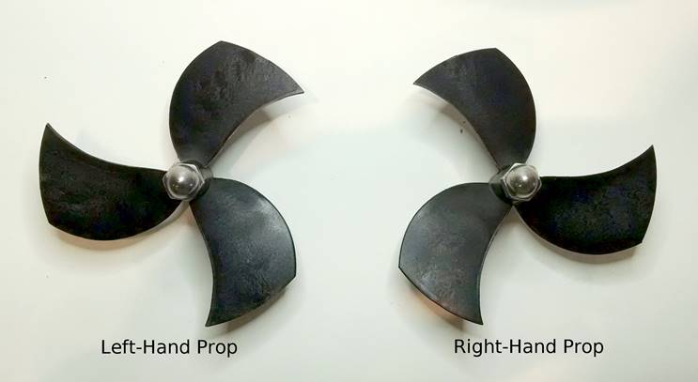Device ID: 0